Grundvig Project Meeting in Izmir.
Some personal reflections on a cross-cultural event.
Gertrud Goudswaard
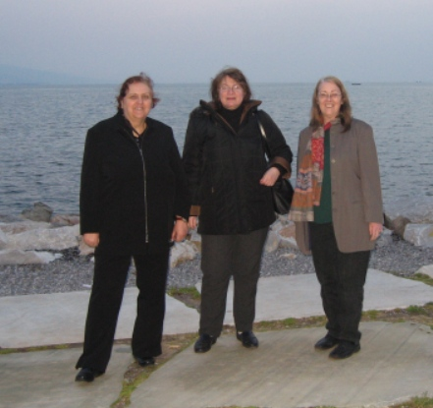
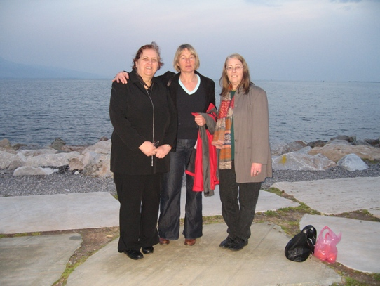

March 10
We were four of us representing four different countries; Karin from Germany, Irina from Russia, Rita from Ukraine and Gertrud from Holland. Four impulsive women of 50 plus with completely different backgrounds, histories, perspectives and expectations, now living in the same country and travelling with one common destination; Izmir, Turkey!

We met the Polish delegation at Munich airport and arrived in Izmir as scheduled.
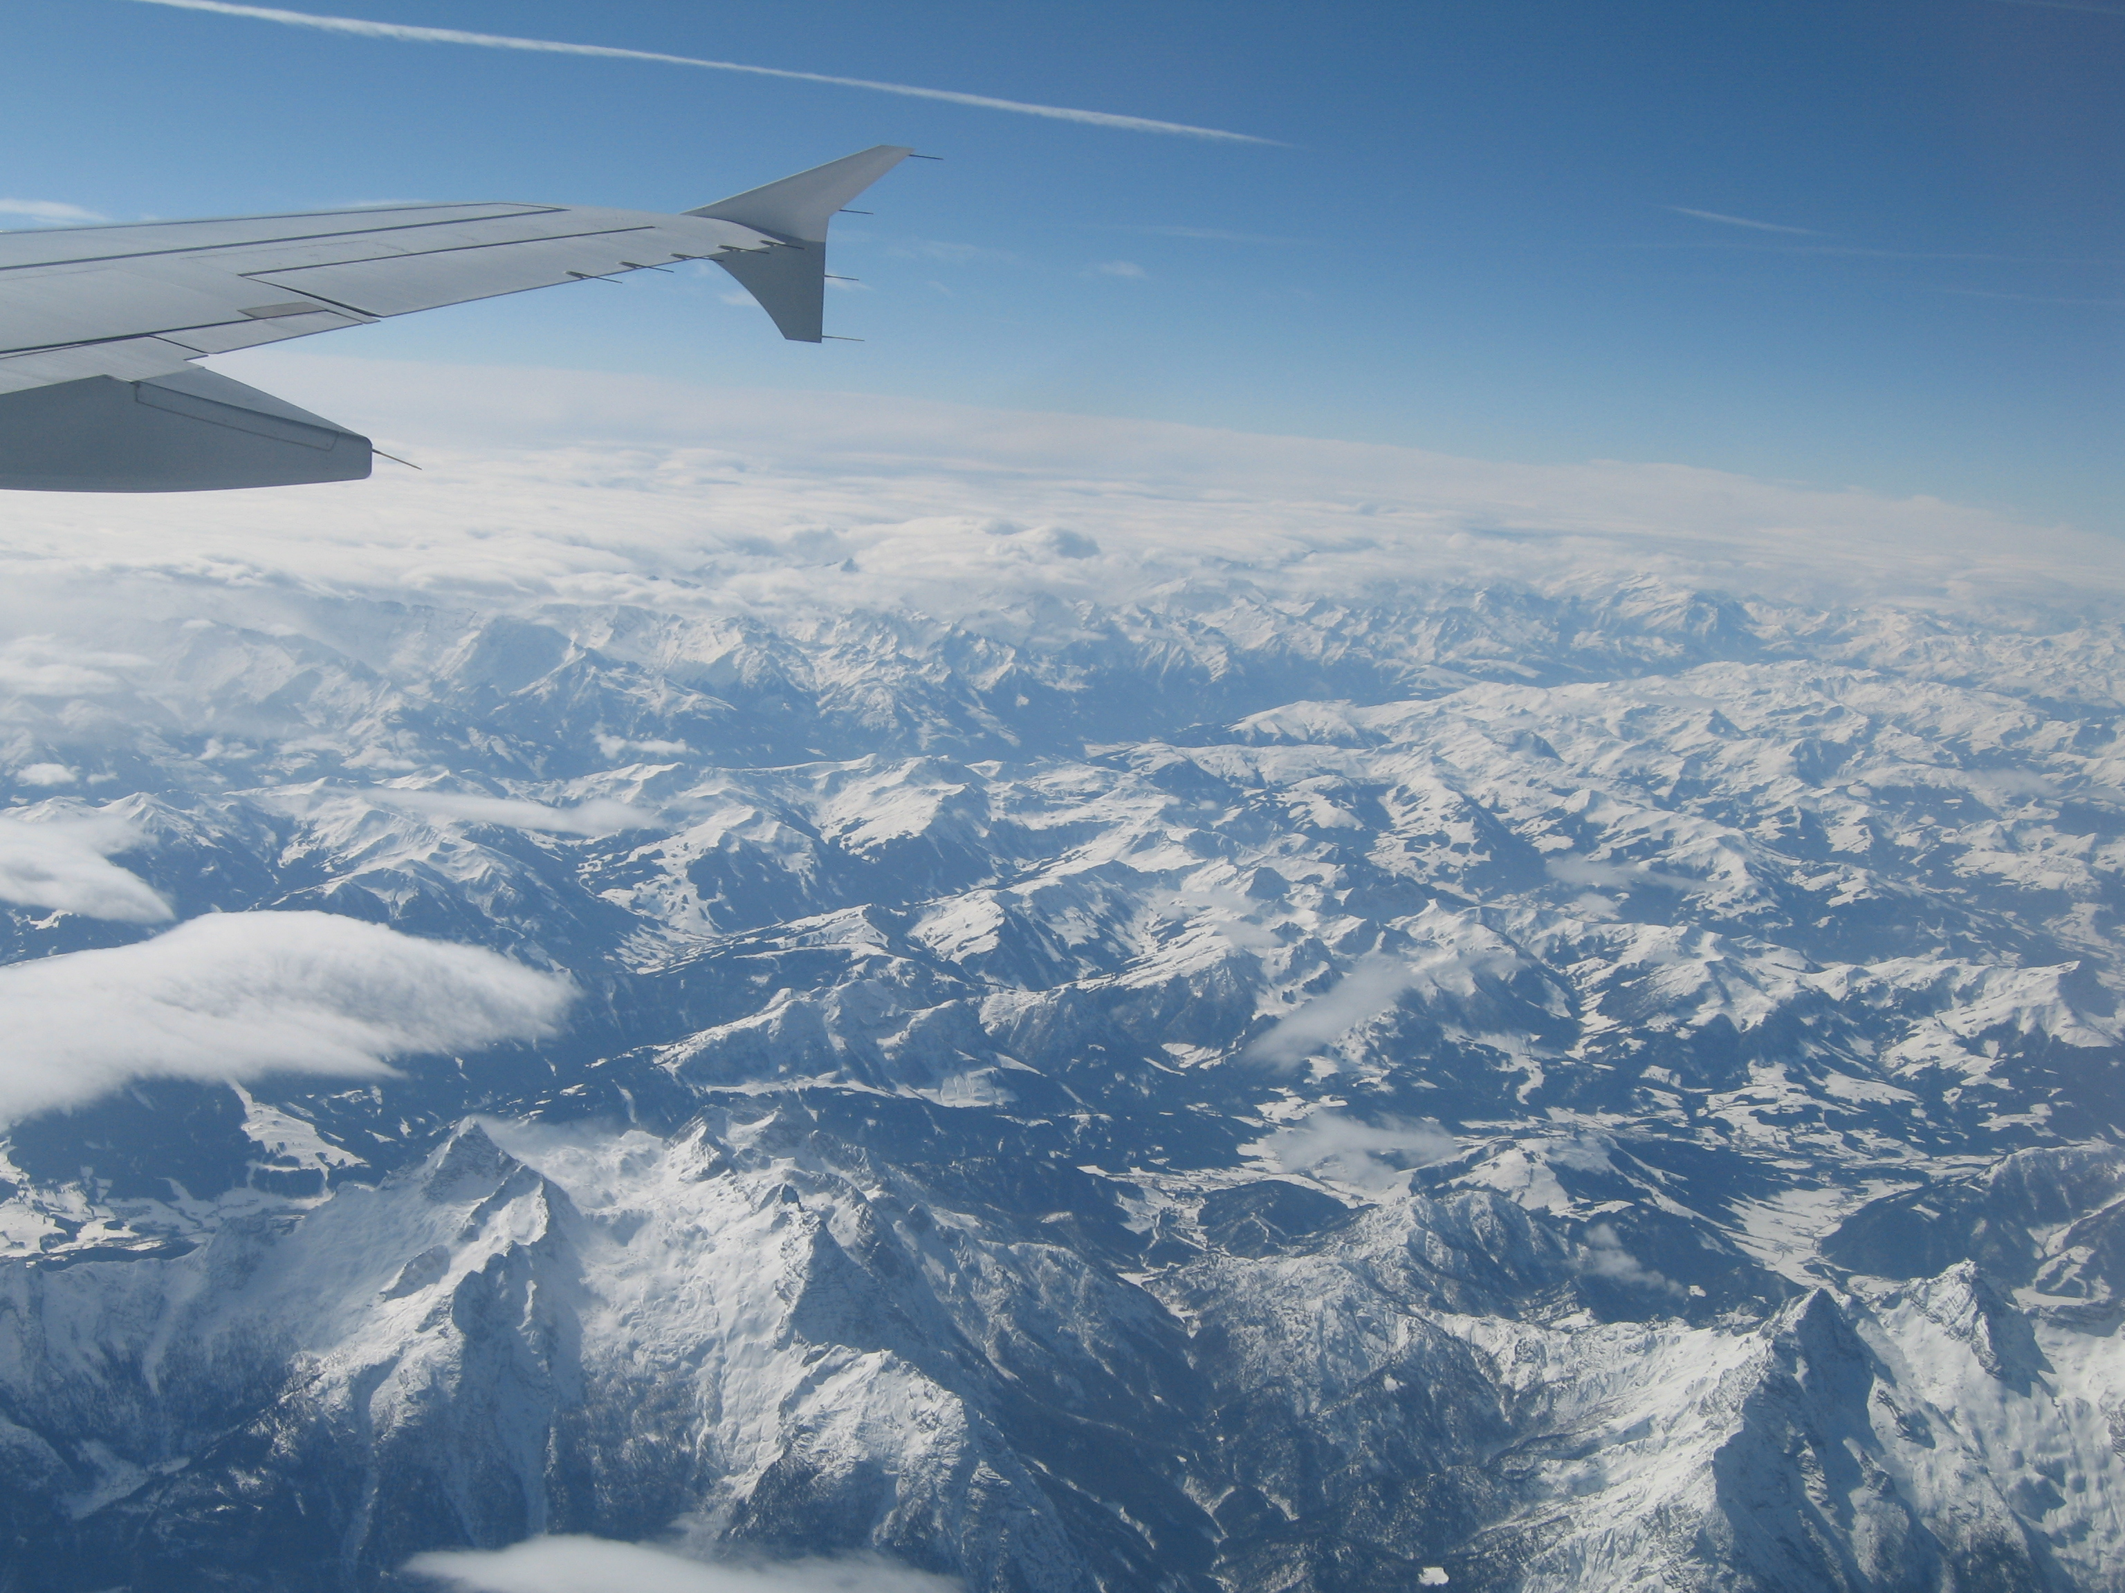

Following Aykut's advice on haggling with the taxi driver over the price of the fee we asked him not to use the taxi meter (how very un-German) but to give us a fixed price and we were quite happy about our small success. When in Turkey, do as the Turkish do!
Our next pleasant surprise was waiting for us in front of the hotel; Aykut and his mother who gave us a hearty welcome. "Something to remember when I am expecting guests", I thought and upon entering the hotel lobby, we again were welcomed by other members of the Turkish delegation. Our rooms were wonderful and there was a "delightful" Turkish welcome gift for each of us on the sideboard; a small bowl with the typical Lokum. I could not imagine a sweeter welcome. The good atmosphere for the Izmir project was herewith established and remained throughout our stay!

March 11
We decided to go and explore the city and asked for some advice on busses at the reception desk. How helpful it would have been if we had known some Turkish! How awful this feeling of not being understood, of not being able to communicate and being a total outsider and how wonderful it is when someone helps you! One of the waitresses took us outside and showed us the bus stop. She also wrote a telephone number on the business card of the hotel, in case we would get lost. That was very considerate of her, just as we thought it was very considerate of the man at the reception to remind us not to leave any money in the hotel room. "No money room?" he kept asking and we assured him "No, don't worry there is no money in the room". It took us a few days and the explanation of Aykut to understand that we should have paid our room upon arriving and not upon leaving, as we are used to in Germany. How deeply these habits are rooted that we had never thought of this before!
This experience gave us some idea of how foreigners must feel when they enter our country and make mistakes because they do not know the language and do not know our habits. It confirmed the importance of intercultural competence and made us aware of our own deficits in this field.

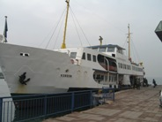
At the ferry to Konak, the old city centre, we had some Turkish tea and Turkish teaching by a very friendly waiter who was obviously amused by our linguistic endeavours.
A young man who studied mechanical engineering also helped
out and took the opportunity to tell us about the admission exams and how difficult it was to get a placement at a university. Thus, the trip was very informative and we felt that our interest for the country was well-received by the Turkish population. It is a nice experience to be addressed
spontaneously by total strangers, something that would probably be frowned upon in Germany, where we rather mind our own business.

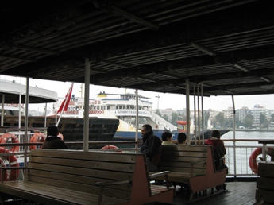
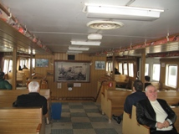
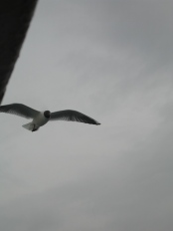
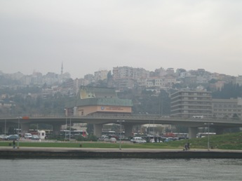

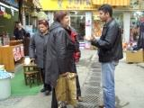
In Konak we were spotted as potential customers by a shop owner who addressed Irina in fluent Russian and brought us to his shop. He told us he was married to a Russian woman and his children were taught in both Russian and Turkish. We were invited for a glass of tea and witnessed the wheeling and dealing of Turkish negotiations. First of all one tries to build up a nice atmosphere and the last thing you discuss is the price. Maybe the price was a bit too high but this experience was priceless!

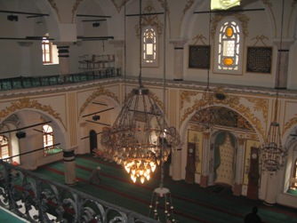
Another person who had worked in Germany and knew amazing details about Holland, (hurray for globalisation) showed us around and brought us to a Mosque and informed us about the praying rituals. We were all very much impressed by the tolerance shown there. We were in the men's department without any objections and after that we went to the women's department where we saw a man sitting and praying. And yes.... of course we had covered our heads with a scarf and it looked quite natural.

The evening was a wonderful mixture of Turkish arts and crafts, shown in an exhibition of the Çiģli Adult Education Center, Turkish food, music and traditional dance. The pictures Sylvia sent us speak for themselves and I think we will all agree that the evening was a big success.
Sie sind eingeladen, das Album von 102365151763307070869 zu betrachten: Izmir Grundtvig-Projekt Impulse 50+

March.12
See the detailed minutes of the meeting written by Sylvia.

Work.
Although the time was short, the outcome of the group discussions was very revealing. The differences in political situations, in family relations and in educational systems that came up in our groups are just a small and promising preview of what we can expect from the upcoming interviews. The information we may get from the interviews will help us to understand and explain certain cultural and political phenomena.
For me, this workshop confirmed the importance of this project in that it offers a wonderful opportunity to get to know and appreciate different cultures and to become aware of one's own culturally determined perspectives. It was interesting to witness the differences in the way we structured our work (time oriented versus relation oriented), the different ways in which we presented our results (precise, neat and detailed versus general, vague and casual), our different styles of communication (direct versus indirect, emotional versus factual), our time management etc. This group of people showed the whole range of cultural features. A dream group for any trainer in diversity management! Working effectively across cultures means being able to cope with and benefit from these differences. I see this as the most important message and goal of this project.

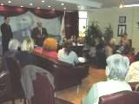
After the workshop we were brought to the office of Metin Solak, head of the Çiģli district, who received us with tea and gifts. We were all somewhat impressed by the size of the desk, the beauty and luxury of the office and the official character of the reception. Even the press was there. In this country, heads are still heads and respected as such. Hierarchy is still celebrated and accepted and we were treated as important guests.
We were shown around the rest of the building and were warmly welcomed wherever we came. With our lovely gifts we went back to the bus and were brought to the workshops of the educational center.

Our mother hearts melted upon seeing the children in Kindergarten and I noticed how one of the little boys, who was fooling around and not really listening to the teacher, was picked up by an assistant who put him on her lap and cuddled him to quiet him down and I felt that this was a good place for children. No cultural differences here. Care and affection is what children need all over the world!
We were also shown the sewing, the baking and the woodworking department and could see that the people were proud of their work and their products.

We finished the day with a short walk through the city and had a drink in the old and beautifully restored caravancery :Turkish coffee without, with or with a lot of sugar.
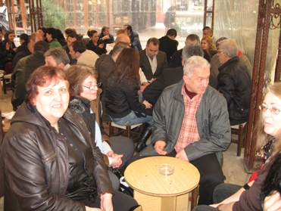
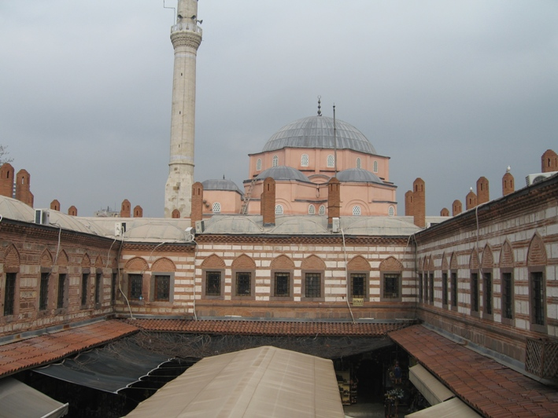

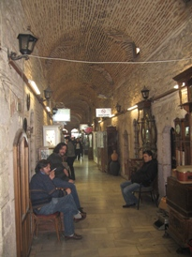

March 13
After having been able to enjoy the culture of everyday life in Izmir, we went on a trip to the antiques to witness some of the remnants of the old culture in Efesus. The weather gods were gentle to us and we could enjoy a wonderful early spring time. Aykut and Deniz took the trouble to rent a tape recorder guide and I stayed close to them to hear them talk about the wonderful places we saw. The group was scattered all over the place and we found some sitting on the highest seats at the arena, enjoying the view and the lovely atmosphere of this place. Although we should have been at the bus at 14.00 hrs, nobody seemed to really care about the time and nobody pressed us. Wonderful when you can just forget about the time and enjoy the moment! It is something we often forget in Germany, where the clock is the main director of our lives.
Unfortunately the battery of my camera broke down but I have the scenery imprinted in my mind and can always go back to the pictures Sylvia sent us.
Our last visit was to a picturesque mountain village called Şirince where we had lunch and strolled through the narrow streets with little stalls. Tired and satisfied we went back to the hotel and for a bus full of 50 plus women, it was rather quiet. Aykut could finally relax and dose off. He deserved his nap because he had surely organised an unforgettable day.

March.14
Time to say goodbye! Bit by bit groups were leaving and quickly the last addresses were exchanged. Some hugging, some shaking hands, some promises, some wishes flying through the air. It is always a bit difficult to let go after such intensive days but I think most of us were also tired of the many impressions. The lucky ones whose plane left later were taken to the Zoo. This was a very relaxing excursion which gave some time to think things over and enjoy the beauty of nature. The Zoo was built according to the newest ideas where the animals are held in quite natural environments and you get the impression that they are watching you instead of the other way around. This Zoo with its various animals from various countries, built by various countries, is a good example of a successful international cooperation in which Austria happened to play an important part for its construction and development. Somehow this seems to be a very appropriate ending to this story about the 50 plus Impulse project.

Thank you all for the lessons learned, the mutual interests shown, the intimate conversations and the warm hospitality.

Gertrud Goudswaard.
